# CS 255 System Design Document

## UML Diagrams

### UML Use Case Diagram

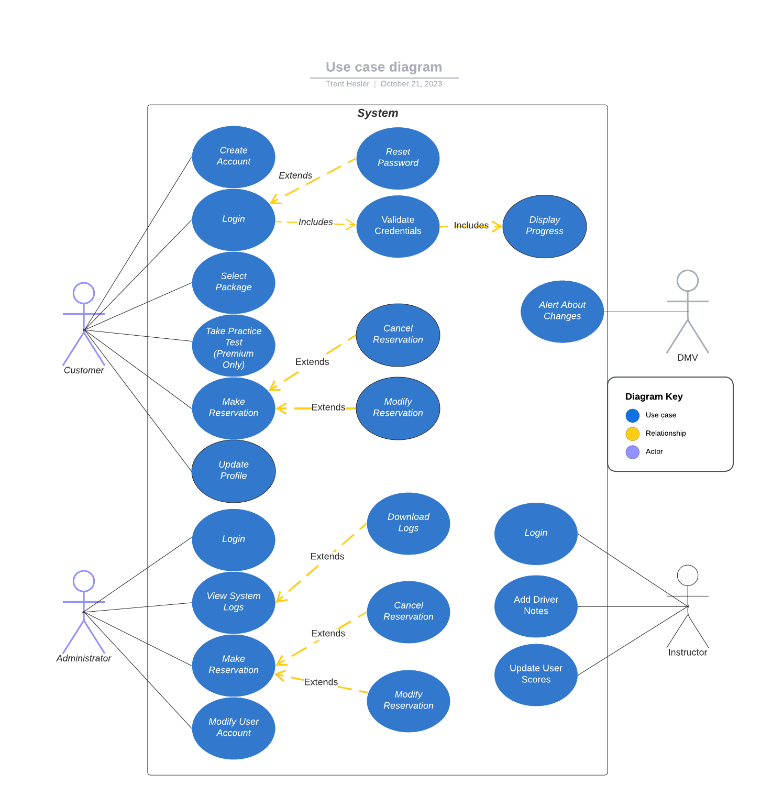

### UML Activity Diagrams

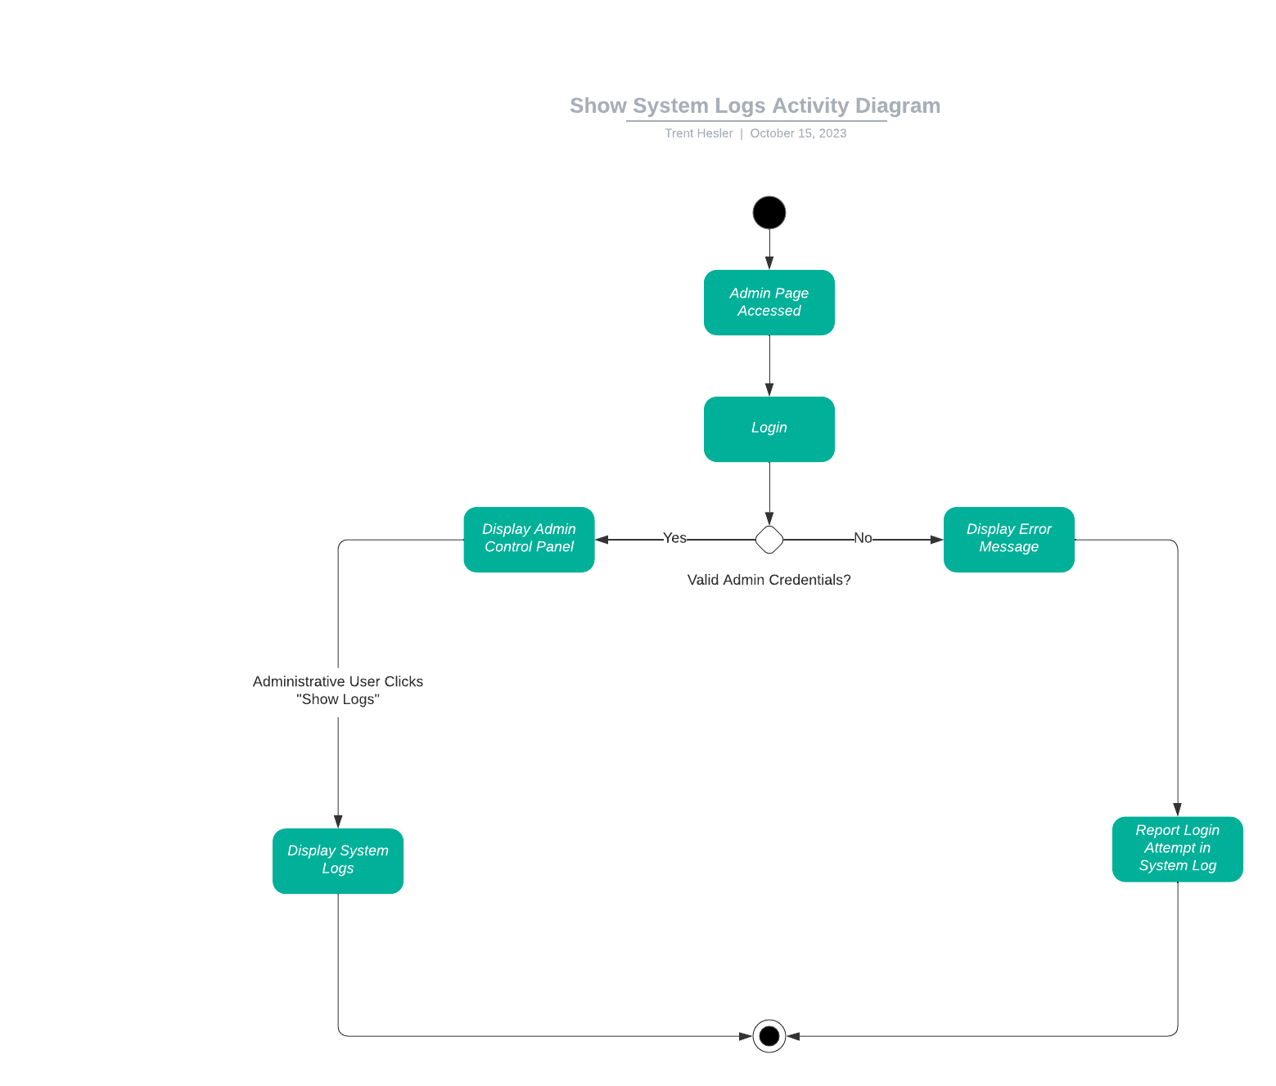

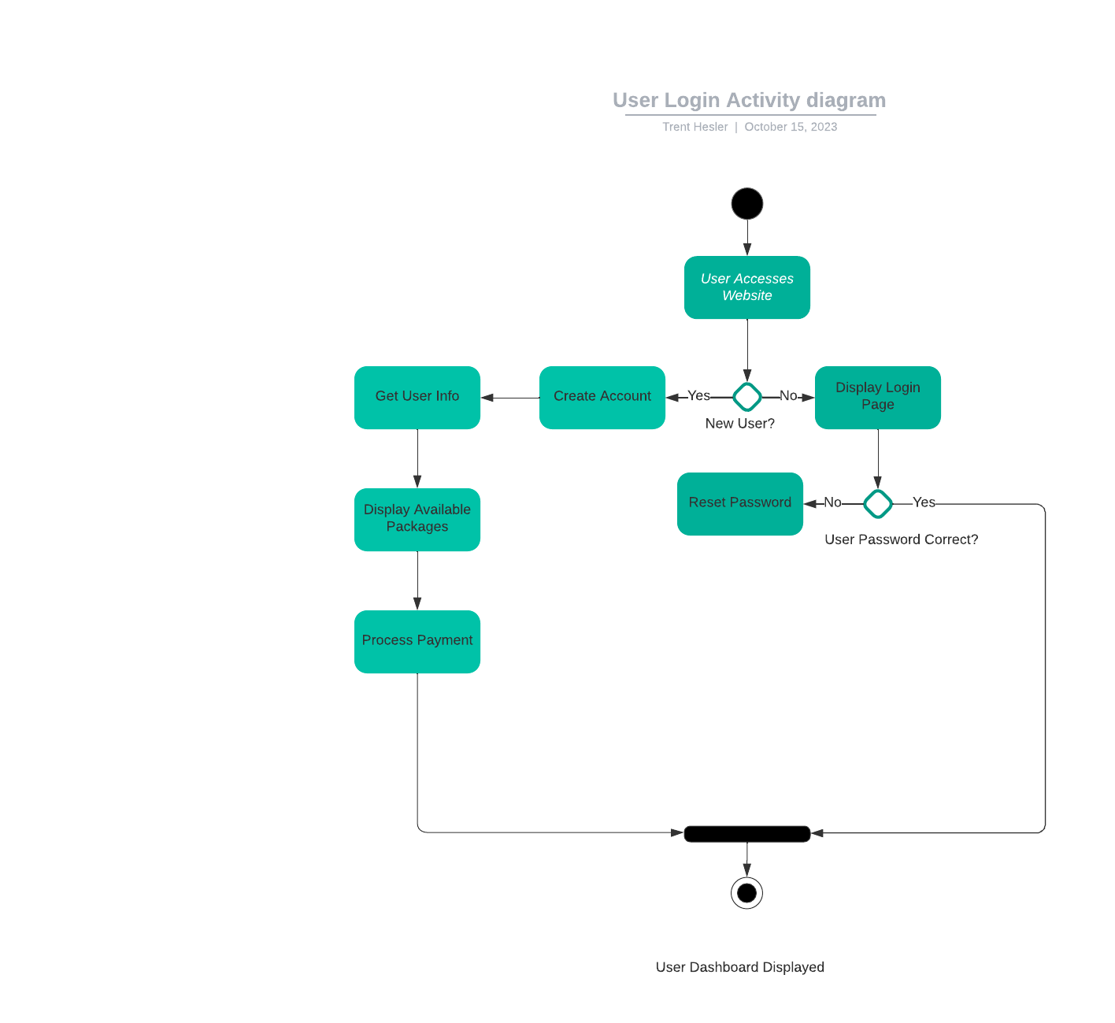

### UML Sequence Diagram

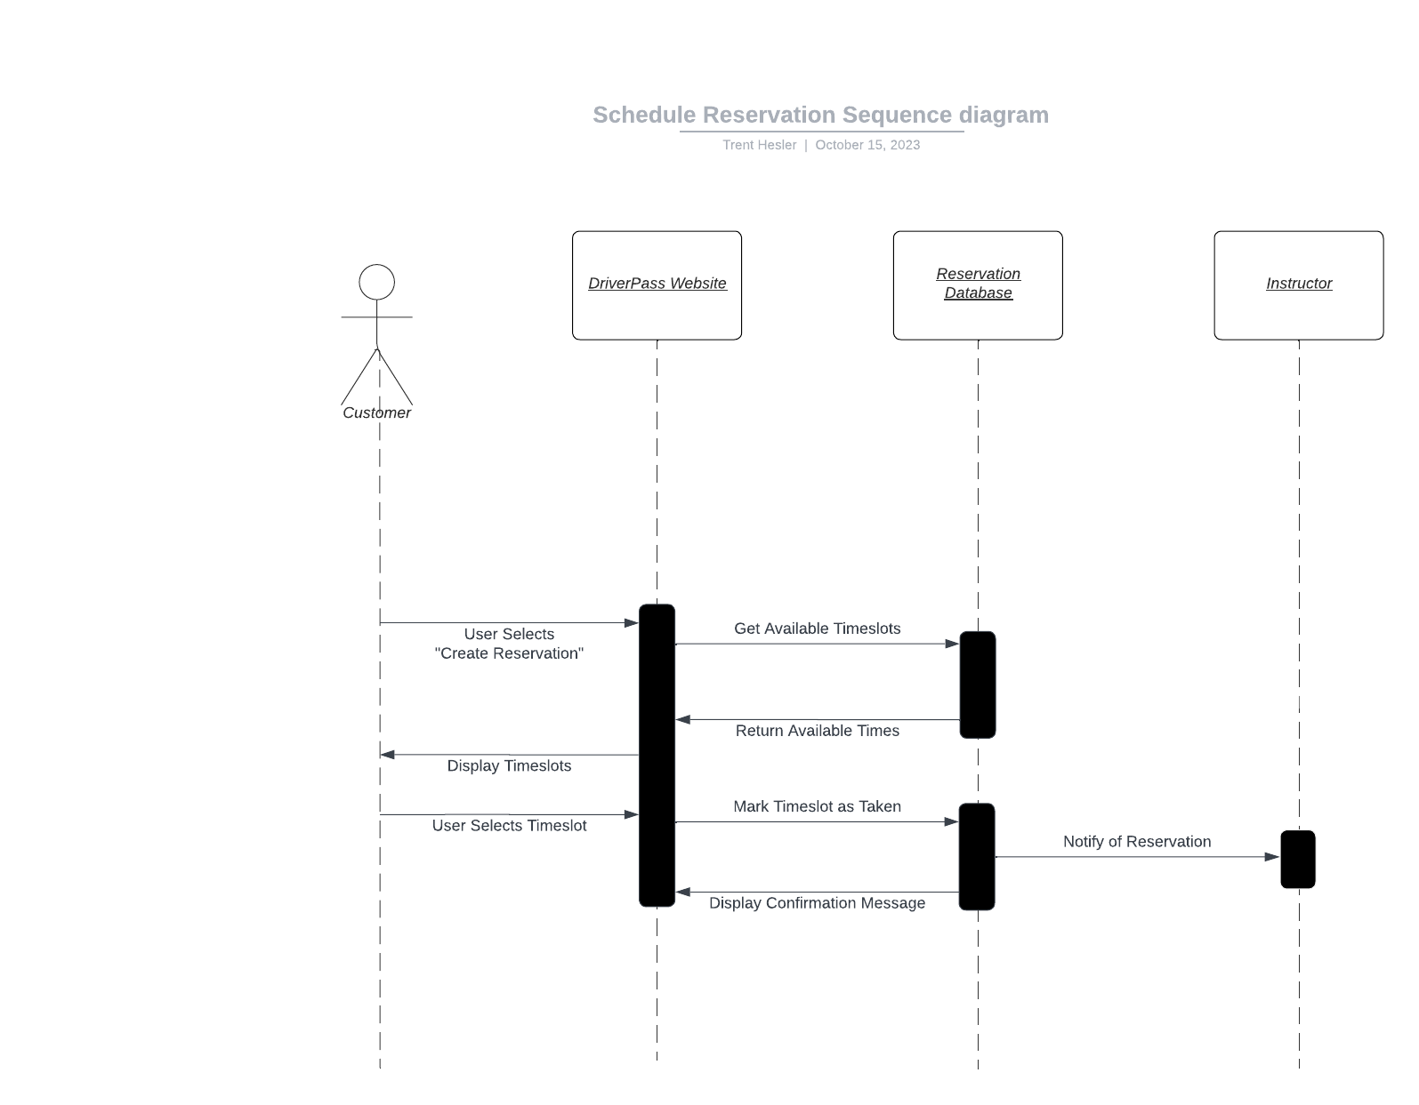

### UML Class Diagram

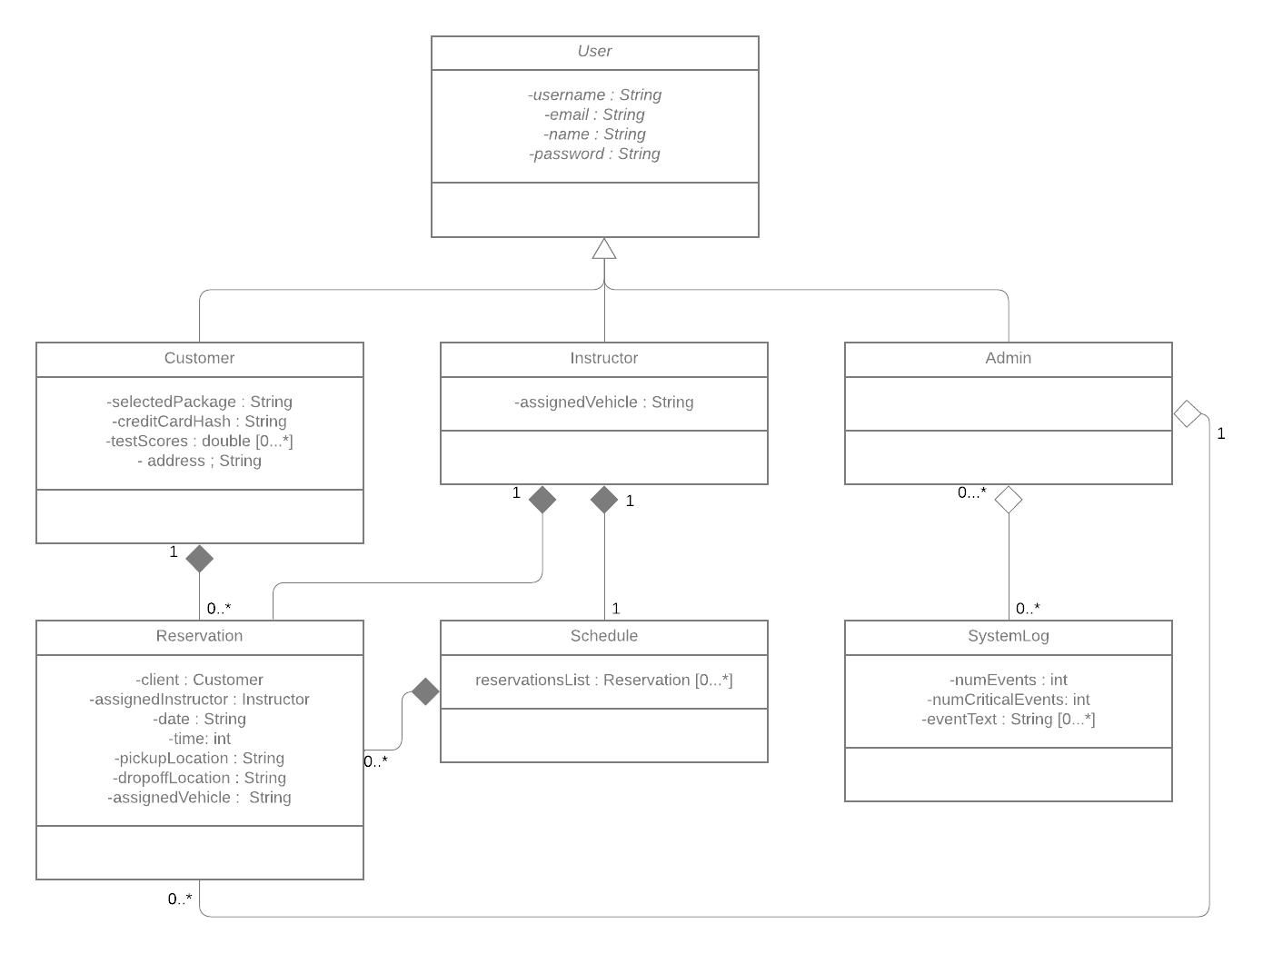

## Technical Requirements

**Hardware**

* **Client:**
  + A desktop computer, laptop, or internet-connected mobile device
  + A valid credit card
* **Host:**
  + A cloud server
  + Desktops, laptops, or internet-connected mobile devices for administrators and instructors
  + Some sort of backup solution (magnetic tape, CD/DVD burner, etc.) for backing up and storing long term data
    - Cloud hosting provider will also provide backup services, but is best to have multiple backups

**Software**

* **Client:**
  + A modern web browser
  + An email client
* **Host:**
  + A modern web browser
  + Development software
  + Cloud management software
  + Operating system for the cloud server
  + Error logging software
  + Encryption software
  + Intrusion detection software
  + Software firewall (Assumption: Cloud hosting service will handle hardware firewall)

**Infrastructure**

* **Client:**
  + An internet connection
  + An email account
* **Host:**
  + An internet connection
  + A connection/method of correspondence with DMV
  + Telephone connections
  + Subscription to a cloud hosting service
  + (Optional) GeoIP lookup service (to ensure customers are located in US)